|  |
| --- |
| Name: |
| Student Reference Number: |



|  |  |  |
| --- | --- | --- |
| Module Code: | Module Name: | |
| Coursework Title: | | |
| Deadline Date: | | Member of staff responsible for coursework: |
| Programme: | | |
| Please note that University Academic Regulations are available under Rules and Regulations on the University website [www.plymouth.ac.uk/studenthandbook](http://www.plymouth.ac.uk/studenthandbook). | | |
| Group work: please list all names of all participants formally associated with this work and state whether the work was undertaken alone or as part of a team. Please note you may be required to identify individual responsibility for component parts.  ***We confirm that we have read and understood the Plymouth University regulations relating to Assessment Offences and that we are aware of the possible penalties for any breach of these regulations. We confirm that this is the independent work of the group.***  Signed on behalf of the group: | | |
| Individual assignment: ***I confirm that I have read and understood the Plymouth University regulations relating to Assessment Offences and that I am aware of the possible penalties for any breach of these regulations. I confirm that this is my own independent work.***  Signed : | | |
| Use of translation software: failure to declare that translation software or a similar writing aid has been used will be treated as an assessment offence.  I *have used/not used translation software.  If used, please state name of software………………………………………………………………… | | |
| **Overall mark _____% Assessors Initials ______ Date_________** | | |



**Servers, Datacentres and Cloud**

**PUSL2010 Coursework 2020**

Contents

1 Introduction - PART I 1

1.1 Introduction 1

1.2 Analysis 1

Technology Justification 7

Workload 14

Bibliography 15

References 15

Table of Figures

Figure 1: Illustration of trends for SaaS (AALPHA, 2020) 1

Figure 2: Illustration of Growth in Remote Work (flexjobs, 2020) 2

Figure 3: Illustration of the Food Management Network 6

# 1 Introduction - PART I

## 1.1 Introduction

Our objective is to select a proper infrastructure which will provide more functionality than the current infrastructure that is being used. And from we must select a specific infrastructure and determine why it is better than the rest of the infrastructures, the options are traditional server deployment, virtualized deployment and in housed (on site) or off-site (ISP) based deployment.

In the project analysis we determine all the features and functionalities the project must accomplish along with all the risk that we may have to face during the duration of the project so in the analysis we must find these risk and come up with a solution if these risks occur in the future. Having the proper infrastructure is crucial as it provide services to end user so having a good infrastructure can help the organization and as the head of IT operations, we need to ensure that the customer services are satisfied.

## 1.2 Analysis

The supermarket being a large network and operating daily requires a lot of capacity within the system handle numerous transactions without failure.

As the business grows more and more data would be transferred and stored to keep the business in firmly stable with the competition, this requires new equipment to handle network traffic, faster storage drives, accurate GPS modules and more robust IPDS so as the requirements grow more space is required for them. Virtualization could help to overcome this problem in a more economical way sustaining the traditional servers within the chain.

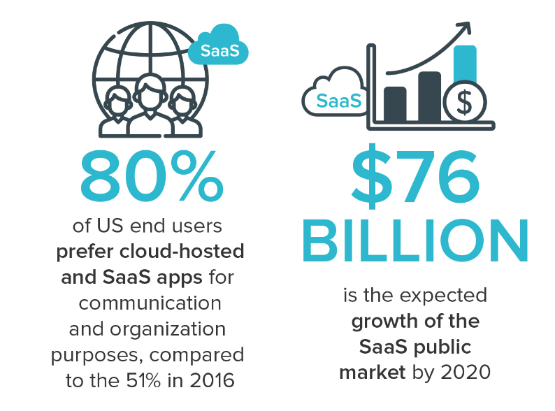

Figure 1: Illustration of trends for SaaS (AALPHA, 2020)

Most business platforms today run on the Cloud, this helps to work on the go for staff and reduces extra store space required to store serves, and maintenance costs. Due to fact that most business move the SaaS model (Software as a Service), it will be profitable for the Supermarket chain to move the IT Infrastructure to the Cloud. (FinancesOnline, 2020)

Upgrade will make expansions and future upgrades to the IT Infrastructure more flexible and safer from damages as personalized services as offered by partners businesses. If the Company requires to store company’s sensitive material, the old servers can be utilized for this, making the upgrade more economical and approachable to the company.

Statistics show increasing trends for people requiring working from home and for administrators requirements to maintain systems from one service point where actions can be assigned, monitored and controlled. This shows clear evidence for the requirement of the supermarket chain to move to cloud-based infrastructure as studies done by FlexJobs and Global Workplace Analytics shows “that there has been a major upward trend in the amount of people working remotely in the U.S. In the span of one year, from 2016 to 2017, remote work grew 7.9%. Over the last five years it grew 44% and over the previous 10 years it grew 91%. Between 2005 to 2017, there was a 159% increase in remote work. In 2015, 3.9 million U.S. workers were working remotely. Today that number is at 4.7 million, or 3.4% of the population.” (flexjobs, 2020)

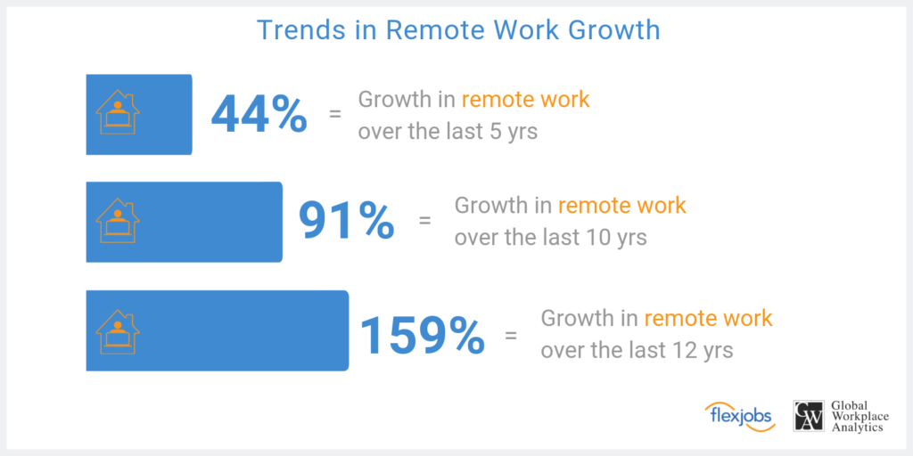

Figure 2: Illustration of Growth in Remote Work (flexjobs, 2020)

As to the provide scenario in the assignment brief, this supermarket chain is planning to modernize their operations by tracking their goods’ statistics like quantity, sales rate, coordination of regional departments and to provide online shopping services. Day by day passes by the ratio of consumers buying their goods from online than attending to the store is raising gradually. So, companies should start providing their services via online to gain a profitable margin in the years to come. This interacts directly to providers like supermarket chains as they provide to extreme essentials people require daily.

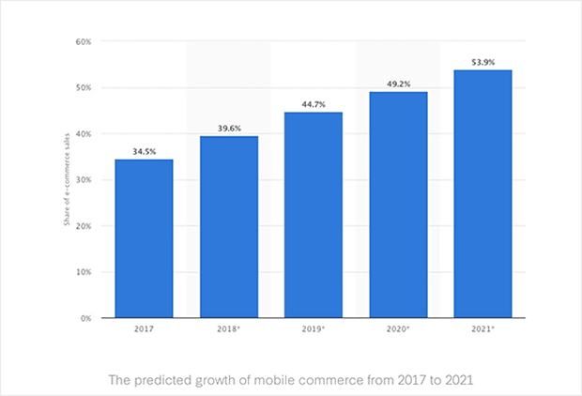

*Figure 3: Illustration of Statistics Raising for Online Shopping (Ouellette, 2020)*

According to the future predictions of online shopping there will be 54% dominating the sales sector in 2021. This means half of the goods sold are either delivered to the buyer’s home or product is sent to a pick-up outlet. The main purpose for the majority interested in online shopping is due to the consumer time allocation to execute the task is less. But in terms of store shopping the instant interaction and purchase of goods is the beneficial perspective.

This supermarket chain’s main goal is to implement their own IT system and infrastructure to operate the supply chain efficiently and reliably. This brings to different perspectives in benefits and drawbacks for this supermarket chain.

Benefits:

* Data operated in the IT infrastructure is physically located under the supermarket chain’s supervision and full control over their data.
* Can instantly maintain the network and hardware equipment is necessary,
* There are less vendor limitations in further developing the IT infrastructure.
* Physical interaction to the hardware equipment will only be done by the organization’s trusted employees.

Drawbacks:

* Additional IT sector in the organization is required to monitor and maintain the network.
* More costly to run an IT infrastructure by the organization than handing over to a vendor due to the maintenance of constant usage in electricity, data bandwidth, and water. Monitoring and managing a network take a lot of resources as it’s an addition operating cycle for the organization. An IT infrastructure required for such organization requires servers, these servers are meant to be handled in certain environments like the temperature should be 19 to 24 degrees Celsius and the humidity should be at 70%. Backups systems like power back solutions, data backup solutions are required.
* High security threats and lack of experiences in handling such incidents.

These are just several benefits and drawbacks the organization would face after the installation of their own IT infrastructure.

And one drawback would be this IT infrastructure requires a tactical planning by professionals and hire skilled people to operate this new section of the daily operations. This is a crucial element as it leads to the outcome of the supply chain.

During this progression, the supermarket chain is planning to implement several functionalities,

* An option to shop online where consumers can receive the goods home delivered or collect it as a pick-up outlet.
* Quantity of goods available in the outlets and regional stores will be monitored and new stocks will be requested from the distributors.
* The monitoring and management of the supply chain will be handled by the head office of the supermarket chain 24/7.

They plan to implement such services by the use of IOT (Internet of Things) and GPS devices. Also, the security of network infrastructure will be secure as to the monitoring of the daily activities done in the supply chain.

Details about the Infrastructure

Each of these infrastructures has their own pros and cons and as the heads of IT operations it is our task to determine an infrastructure that is suitable for the organization. here is some information about each of these infrastructures which may be helpful when deciding an infrastructure for the business.

Traditional server deployment

The traditional server deployment has its pros and cons which may affect the decision of the infrastructure. Some of the pros are High performance and specialized hardware and another advantage is that. The disadvantages are inability to virtualize and expensive disaster recovery and these are only some of the drawbacks to this infrastructure and should be considered when choosing.

Virtualized deployment

Server virtualization is a software architecture that allows more than one server operating system to run as a guest on a given physical server host. Some of the virtualization platforms are VMware, Xen and KVM. The virtualized deployment has its pros and cons some of its pros are less maintenance cost, less physical server and less energy cost. But this infrastructure also has some cons sing point of failure and high stress on single machine. So, deciding whether this infrastructural is perfect for the business depend on the type of business and functionalities the business needs to provide to the customers.

In housed or off-site based deployment

This infrastructure also has its pros and cons when it is chosen Just like the other infrastructures. Some of its pros are that Gives you physical control over your backup, keeps critical data in-house so No third party has access to your information and No need to rely on an Internet connection for access to data. Then there are some disadvantages for this infrastructure, and they are Needs space in your workspace for a rack or server, dedicated IT support and No uptime or recovery time guarantees. So, it depends on the business whether this infrastructure in suitable to the business.

Project success

The project will be a success when the correct infrastructure is chosen and has a clear understanding why this specific infrastructure is better than the current and from the other options that were available and what are the new functionalities it will provide. In addition, the infrastructure should be implemented and completed within the given time period and the budget for the project to be successful.

In the given scenario we must implement a supermarket infrastructure to make the current transactions efficient. The supermarket infrastructure consists of

* Sales outlets (supermarkets)

Provide shopping facilities to online and traditional Customers. The Online purchases will be delivered via transport or customers will be able to pick it from the nearest supermarket.

* Storage and logistic centers.

The stocks sent from farms will be stored here. Depending on the demand provide supermarkets with stocks.

* Transportation system

Transport goods from each outlet.

* Head office

Implement security via a command and control station.

Communicate to any outlet, security focal point via and AOIP.

Monitor every location via CCTV.

Track transportation via GPS and IOT.

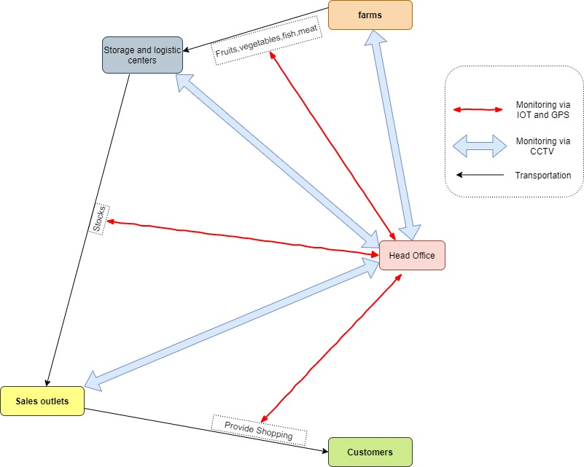

Figure 3: Illustration of the Food Management Network

Project Requirements

* Explain the possible infrastructures in detail (the technologies they use)
* Identify the External and internal users of the current system
* Compare each of these infrastructures with one another (Identify weaknesses and strength of each Infrastructure).
* The current trends / technologies used in Supermarket industry.
* Why the selected infrastructure is better to the given scenario?
* Diagrams of the implemented Infrastructure

# Technology Justification

Today productivity and innovation in a business is a key, few years back cloud computing was an emerging technology but today, it’s being used by airlines, banks, IT companies and almost anywhere we see people use these cloud services from secured online meetings and transactions to personal movie entertainment. Today users are interacting with the cloud than ever before in fact statistics at the time writing show the data usage in a second is nearly 100,000 gigabytes that are made to the cloud. (Our World in Data, 2017)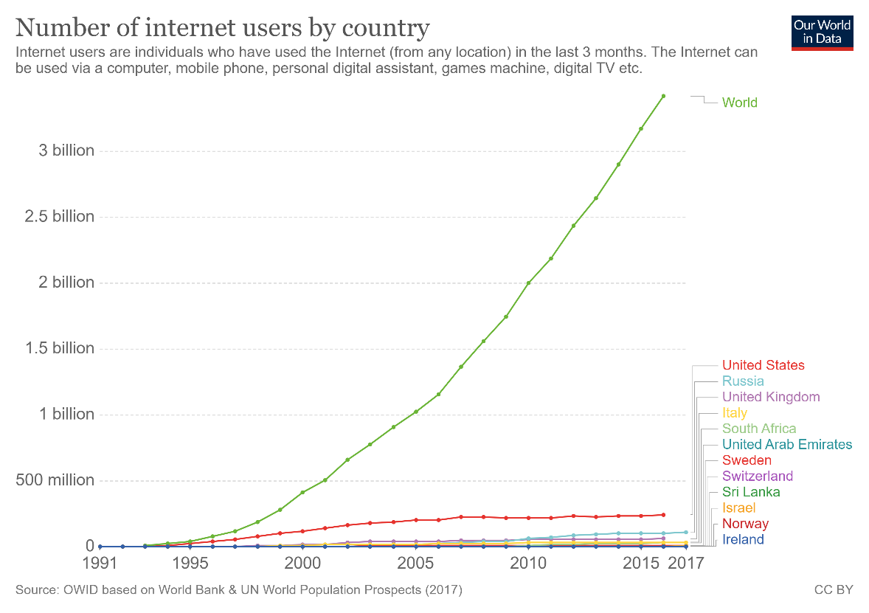

*Figure 1: Graph of Number of Internet User (Our World in Data, 2017)*

Types of cloud computing

There are three types of services on a public cloud, private cloud or hybrid cloud.

**Public cloud**

Public clouds are provided by third party vendors to clients they offer these services usually for free or exceptionally low costs, all the software and hardware are managed by the vender and they allow client to access these resources over the internet virtually.

**Private cloud**

A private cloud usually is stored on a company’s premises for their business use only, this is comparatively costly compared to the method where vendors host the data on their private cloud offsite for low cost as they can virtualize and share resources.

**Hybrid cloud**

Hybrid clouds combine public and private clouds allowing much flexibility for access content within the private and public clouds, this allows a working officer to use the company’s public website to login securely to companies’ private resources with properly authentication. Most business use the hybrid cloud technology today.

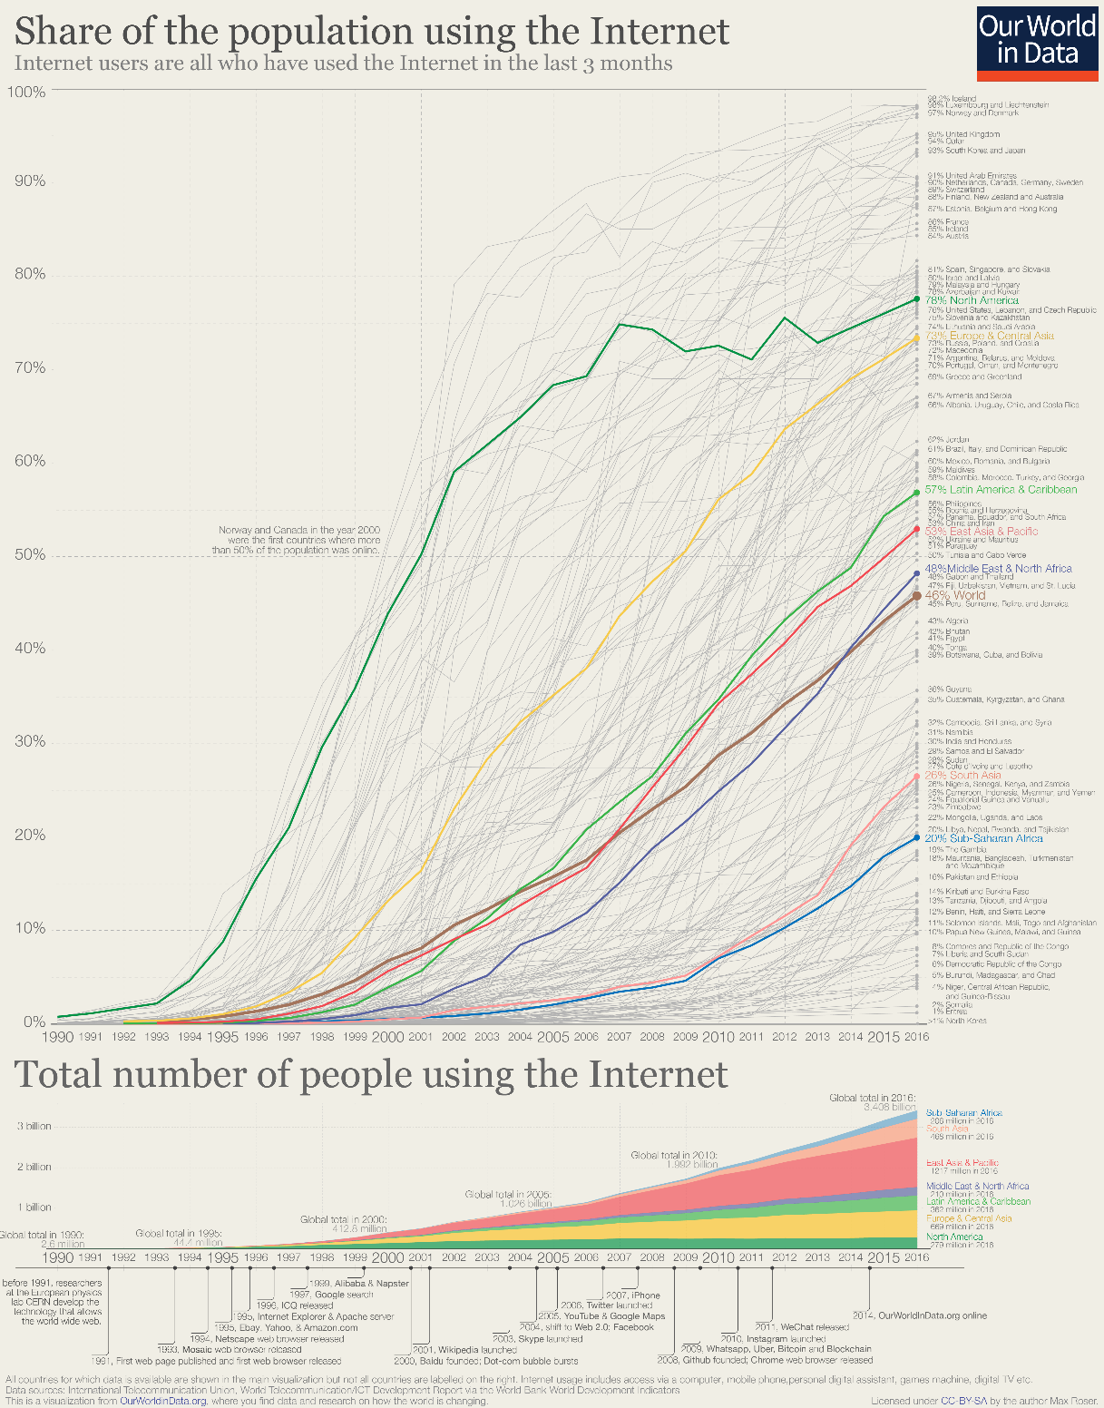

*Figure 2: Graph of Number of Internet User in the World (Our World in Data, 2017)*

Types of Cloud Services

**Infrastructure as a service (IaaS)**

IT infrastructure which includes servers, storage and other hardware are provide for a rental which make this a good choice for most entrepreneurs. i.e. AWS, Microsoft Azure

**Platform as a service (PaaS)**

Platform as a service offers the required hardware and software to be accessed online, similar IaaS but offer more flexibility on selecting a separate operating system and other hardware as platform for software without high level server management. i.e. Google App Engine

**Software as a service (SaaS)**

Software as a service allows users to access and use application using a web browser or similar tool by loading only required assets to the client end, this allows much flexibility and content can be access from any device that has web browsing. i.e. Office 365 Online, Jira, Github

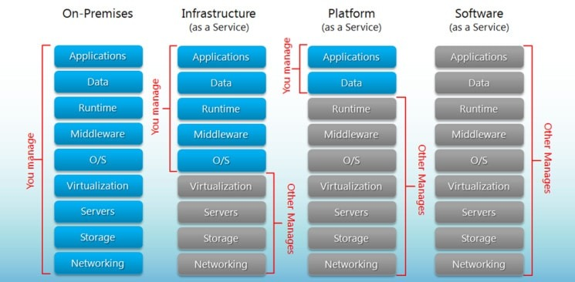

*Figure 3:Comparison Illustration of Iaas, PaaS and SaaS (BigCommerce, 2020)*

Advantages

* Cost Efficiency – Compared to traditional method implementation, maintenance and upgrading cost are exceptionally low. New cloud-based systems are very economical for both startups and large enterprises.
* Backup and Recovery – Data available on cloud allows to quickly restore data and failure rate is low as there are multiple servers to save copies of the same data.
* Storage – Cloud storage allows users to expand storage at very low costs compared to on premises storage disks, it saves costs on expanding building size for storage requirements and economical.
* Speed – Most services provide edge speeds with cloud storage, when they use SSDs but to be benefited by this technology customer should have an internet connection with a good bandwidth of at least 10MBps.
* Global Scale – Cloud systems are assessible from anywhere without extra costs and allows to integrate and work with multinationals with ease, in fact cloud services make little impact on client’s storage, processing power and bandwidth.
* Security – Most issuers supply a satisfactory level of privacy configuration and controls for management and connections are secured using network encryption and storage encryption.
* Performance and Reliability – Datacenters upgrade their components regularly which offers users the best in class experience with their service. With new implementation plans there is less downtimes and slow down as data is accessible from multiple datacenters around the globe.
* Productivity – Deployment of services could be done within few hours compared to on premises storage that usually take weeks to get configured in most cases.

Disadvantages

* Security – There’s considerable risk of data theft when selecting cloud storage as the IT infrastructure of a business in the past, confidential data and financial records have been compromised.
* Network – In order to be benefited clients need have an active network connection and an above average bandwidth to keep a constant connection with the service.
* Technical – There can issues as servers are prone to DDoS attacks and suffer downtime, sometimes even cloud services suffer from internet and power issues which effects client’s business as they have limited functionalities to manage the cloud.
* Vendor Lock-in – Migrating from on cloud service to another is not flexible but new services are being built to mitigate these limitations such as cluster sharing that are provided by SQL Server.
* Support – Communications between the cloud provider and client takes time usually emails take 2 working days or weeks for a response on busy weeks this isn’t acceptable for most businesses.

Cloud computing offers both advantages and risks to a business if not properly implemented, considering all facts it would be better to store highly confidential static data on premises and other data on the cloud which requires regular interactions.

**Traditional server deployment**

The Advantages

* High Performance- Since all the recourse are dedicated and it can handle high stress scenarios.
* Easy to identify problems – It is easy to identify the problem and only one server will fail at a time.
* Easy to use- Since this technology has lasted for a long time there is a small learning curve for the IT department.

The Disadvantages

* Price- The equipment cost will increase over time because more application is equal to more servers and gradually there will be a huge amount of cost for hardware.
* Lack of growth and consistency- Since in order to grow we need add more servers and to do this physical space is needed and management of servers can be difficult, so it lacks growth and is inconsistent.

**Virtualized deployment**

“Server virtualization is the process of using software on a physical server to create multiple partitions or "virtual instances" each capable of running independently”. And we must clearly understand the benefits and disadvantages of using this deployment rather than the other options we could choose from. we could use this deployment if we are planning to reduce the application downtime and simplify backup process or Use more applications and OS without breaking budgets for hardware, electricity, and space and there are more scenarios where this deployment would be preferred so when choosing we must ensure it satisfies our business requirement. In addition, in server virtualization there are three types of server virtualization and they are Virtual machine model, Paravirtual machine and OS-level. So, choosing the type of virtualization of server is also important because it can affect the business.

The Advantages

* Reduced Hardware Costs- Since there are fewer physical servers this will reduce the initial hardware cost that is required for the equipment.
* Growth and Scalability - Since it is running a physical server if we upgrade it then all the virtual instances will also get, and upgrade and another good thing is that less hardware complications and the main thing is it is easy to grow.
* Energy Cost Savings- Since there is fewer physical servers this will reduce the energy cost at a huge rate.
* Simplified backup and recovery – Virtualized servers are easy to recover data because the virtualization software’s has a feature for backup and recovery. This may be from cyber-attack to natural disaster still the data can be recovered.
* Security – A virtualized environment makes it easier to manage the security of the server.

The disadvantages

* High cost for initial setup – Even though overall cost is reduced there is a high cost for initial setup since there is licensing and more.
* It’s not Easy – There is a big learning curve since there are many different types of architectures and different types of software.
* Slow performance – There is a slow performance because of all the stress is on a single machine which my result I longer processing times and finally there are network bottleneck.

**In housed deployment**

In house server are the server that are installed within the premises of the organization

Advantages

* Keeps critical data in-house - Since all the data is within the premises no third party will have the information that is stored, and we have total control of the data
* No need to rely on an Internet connection – The business do not need to rely on the internet to access the data this may be rally helpful if the business is located in a low connection area.
* Can be more cost-effective for small to mid-sized companies- We do not have to pay a monthly fee like for the cloud and since we have control, we can upgrade the server to meet our business requirements along the line

Disadvantages

* Requires a capital investment – A large amount of capital investment is required for the hardware equipment and the infrastructure and this is one of the main disadvantages.
* Needs space – This type of deployment needs space for the servers and more space may be required if we plan to add more racks in the future in addition needs a dedicated IT staff to handle this equipment and make sure everything is working fine
* May be more susceptible to data loss during disaster – The reason is if the business is in an area where natural disasters are common then have an inhouse servers in not a good idea because there is a higher chance of data loss due to these disasters.
* No uptime or recovery time guarantees – Since we take full responsibility, we cannot guarantee a recovery time like data centers.

**Offsite Server deployment**

It is when the company’s data is stored of the premises of the organization in a data center.

Advantages

* Reduce Cost – Storing data in a data center lower the expenses because all the hardware cost, maintenance and energy cost is reduced.
* More Space- We have more space for other things because all the server space is no longer needed for the servers.

Disadvantages

* The main drawback of offsite is that we do not know enough of the data center and it is important that we decide carefully and do some research on them and ensure they have a good record because we will be trusting them with our data.

# PART II

# Workload

|  |  |  |  |
| --- | --- | --- | --- |
| Student Name | Plymouth ID | Work Description* | Contribution as a % |
| Ranul Ladduwahetty | 10673986 | * Analysis * Technology Justification |  |
| Nidula Wijesuriya | 10674049 | * Analysis * Technology Justification * Conclusion and discussion |  |
|  |  |  |  |
|  |  |  |  |
|  |  |  |  |

*Each member signed and filled this workload form.

*For a contribution not filled in the matrix defines that the member was unable to support to the project due to the Covid-19 condition as the time of assessment

# Bibliography

[Apostu, A. (2013) 'Study on advantages and disadvantages of Cloud Computing – the advantages of Telemetry Applications in the Cloud', Recent Advances in Applied Computer Science and Digital Services, Economic Informatics and Cybernetics Department Academy of Economic Studies 15-17, Calea DorobanŃi, Bucharest 4, University POLITEHNICA of Bucharest ROMANIA.](https://pdfs.semanticscholar.org/ada5/876e216130cdd7ad6e44539849049dd2de39.pdf)

# References

AALPHA (2020) *saas users preference*. Available at: <https://www.aalpha.net/blog/how-to-develop-a-cloud-based-saas-application-software-product/attachment/saas-users-preference/> (Accessed: 02 April 2020).

FinancesOnline (2020) *62 SaaS Statistics You Must Learn: 2020 Market Share & Data Analysis*. Available at: <https://financesonline.com/saas-statistics/> (Accessed: 02 April 2020).

flexjobs (2020) *Remote Work Statistics: Shifting Norms and Expectations*. Available at: <https://www.flexjobs.com/blog/post/remote-work-statistics/> (Accessed: 03 April 2020).

Ouellette, C., 2020. *Online Shopping Statistics You Need To Know In 2020*. [online] OptinMonster. Available at: <https://optinmonster.com/online-shopping-statistics/> [Accessed 5 April 2020].

Hou, T. (2020) 'IaaS vs PaaS vs SaaS Enter the Ecommerce Vernacular: What You Need to Know, Examples & More', *BIGCOMMERCE*, 9 April. Available at: [https://www.bigcommerce.com/blog/saas-vs-paas-vs-iaas/#the-key-differences-between-on-premise-saas-paas-iaas](https://www.bigcommerce.com/blog/saas-vs-paas-vs-iaas/" \l "the-key-differences-between-on-premise-saas-paas-iaas) (Accessed: 09 April 2020).

Our World in Data (2017) *Internet*. Available at: <https://ourworldindata.org/internet> (Accessed: 08 April 2020).

The Pros and Cons of Cloud vs in House Servers (2020) *SysGen*. Available at: <https://sysgen.ca/cloud-vs-in-house-servers/> (Accessed: 09 April 2020).

PROS AND CONS OF SERVER VIRTUALIZATION (2016) *techgenix*. Available at: <http://techgenix.com/pros-cons-server-virtualization/> (Accessed: 09 April 2020).